

Flynn’s Website

sanel’s portfolio

Contents

Design brief

design sketch: 2

final concept design:  2

**design changes:…………………………………………………………………………………………………………..**

**evaluation:………………………………………………………………………………………………………………..**

**biblilography: …………………………………………………………………………………………………………….**

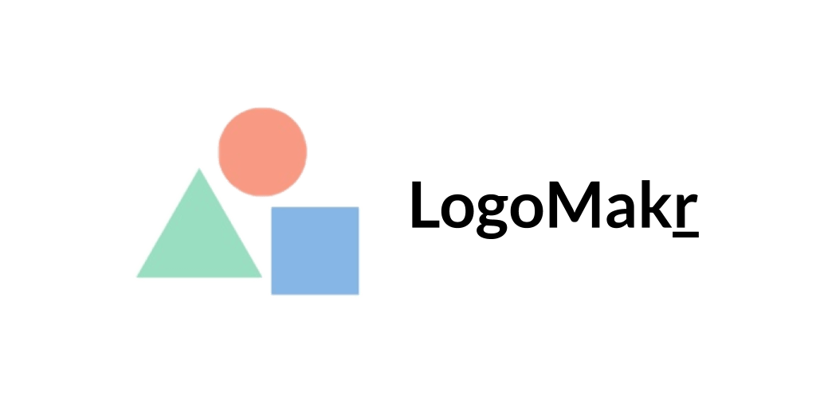Areas of investigation

The website I used to make my logo was logomakr. Logomakr is a very good and easy website to make a logo. It had many tools to help me make my logo, when creating something it bring you to a white screen where you can add shapes or search up other images, you could change the colors of them.



The website/program that I used to make my website was notepad++. Notepad++ is a program that a lot of people use to make a website. We used notepad++ for coding and html which helps a lot while making a website.

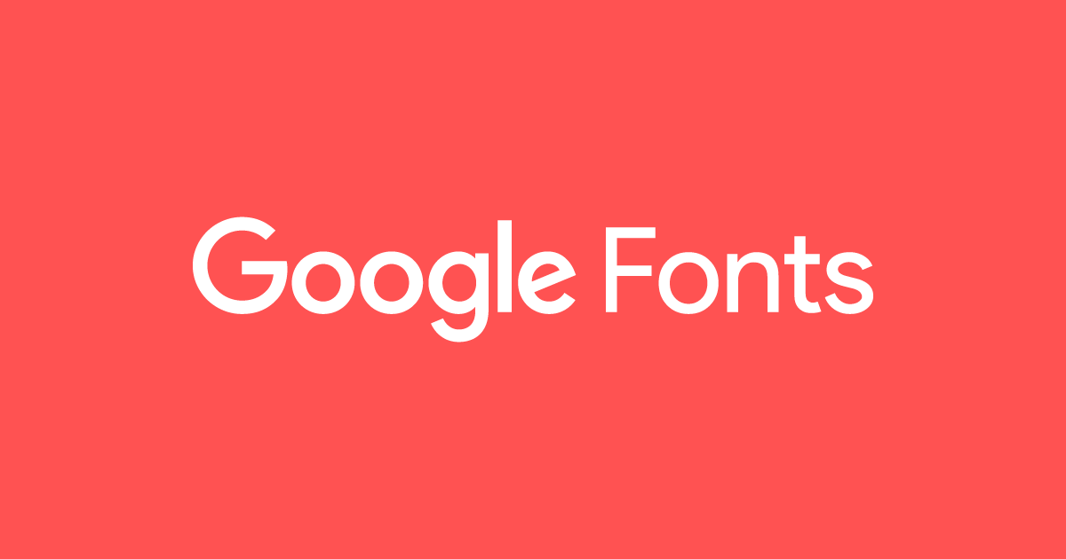Google fonts was a website that I used to get fonts for my website. It has about 952 different fonts and font sizes. It wasn’t hard to use because all you had to do was just browse and picked a font that you liked. You had to pick two fonts, one for your heading and one for your body font.

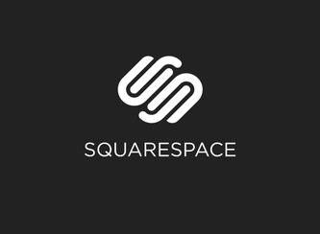

Squarespace is a website creator that is set in New York City. Squarespace is always adding updates and always adding new layouts and improves them. Squarespace has 100 or more themes. There are four different squarespace apps, the most used one is called squarespace which is on iOS.